Course: IS312 – Web Design and Programming

Quarter: Fall – 2022

Name: Trevor Sparks

**Task #1:**

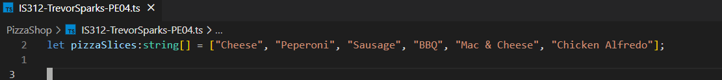

task -1

task 1-2

**Task #2:**

task 2-1

**Task #3:**

task 3-1



Task3-2

Task3-3

**Task #4:**

It is one thing to read a textbook or lecture slides about how to implement a concept when programming. It is a whole other thing when you finally get to actually writing code. For this programming exercise, the first two tasks went smoothly; I had no problem coming up with ideas for interesting pizzas or their prices (I went to a pizza shop one time where every type of pizza was the same price, so I tried to include a little bit of that). However, I struggled a lot with task 3-3. My knowledge of how to manipulate arrays is limited to begin with, and this was my first time using the reduce method. Creating the for loop to iterate over the transactions array caused me no problem. However, when it came time to use the array.reduce() method on the array of the names of slices, that is when I hit a wall. Using the reduce method to sum numbers makes sense, but going from there was too much. I could not figure out how to count the number of particular slices. I found an example that looks close to what I want on the Mozilla developer network but I was unsure how to implement something similar here. Here is a link to that page:

https://developer.mozilla.org/en-US/docs/Web/JavaScript/Reference/Global_Objects/Array/reduce